SECTION A
1. In which way is a ventilator useful on a living house?
…………………………………………………………………………………………………..
2. How does sand stop fire from burning?
……………………………………………………………………………………………………
3. Mention one natural source of light.
……………………………………………………………………………………………………
4. In which way is a kink important on a clinical thermometer?
………………………………………………………...……………………………………………
5. Apart from lack of carbohydrates, state any other cause of marasmus.
………………………………………………………………….………………………………….
6. What is the use of a clinical thermometer?
………………………………………………………………..……………………………………
7. In the space below, draw the eggs of a female anopheles mosquito.

8. What type of leaf is a cassava plant?
……………………………………………………………………………………………………
9. How is a ball and socket joint different from that of a hinge joint?
……………………………………………………………………………………………………
10. What type of metamorphosis do tsetse flies undergo?
……………………………………………………………………………………………………
11. How useful is warmth during germination?
……………………………………………………………………………………………………
12. What type of change is sugar solution?
……………………………………………………………………………………………………
13. How is malaria spread?
……………………………………………………………………………………………………
14. Give a reason as to why people wash their hands after visiting a latrine.
……………………………………………………………………………………………………
15. State the structural difference between the foot of a climbing bird and that of a perching bird.
……………………………………………………………………………………………………
16. Give one example of an invertebrate that produces live young ones.
……………………………………………………………………………………………………
Study the diagram below and answer questions that follow.
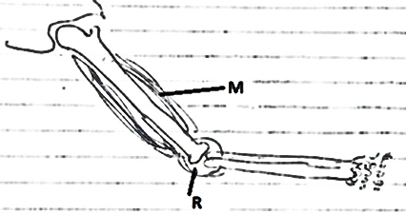

17. What happens to muscle M when the arm is raised?
……………………………………………………………………………………………………
18. Mention the type of joint marked with letter R.
……………………………………………………………………………………………………
19. How do bees produce sound?
…………………………………………………………………………………………………
20. Suggest one source of D.C in our environment.
………………………………………………………………………………………………….
21. Write down one of the causes of natural changes.
…………………………………………………………………………………………………
The diagram below is of two metals joined together. Use it to answer No. 22 and 23.
Before heating


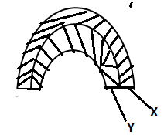
After heating

22. What does the experiment above show about metals?
……………………………………………………………………………………………………
23. Which one of the two metals has got higher rate of expansion?
……………………………………………………………………………………………………
24. How are desert plants adapted to high rate of transpiration?
……………………………………………………………………………………………………
25. State one way how cattle farmers stimulate the milk let down of their cows before milking.
…………………………………………………………………………………………………..
26. Mention one muscular disease which is water borne.
……………………………………………………………………………………………………
Below is a circuit. Use it to answer No.27.

27. Show the flow of electricity.

28. Write down one method of preparing food.
……………………………………………………………………………………………………
29. Apart from proboscis, mention any other body part which some insects use for feeding.
……………………………………………………………………………………………………
30. It took 4 seconds for a man to hear a gun shot. How far was the man from the gun shot? (Take 330ms for sound in air)

31. What type of electricity is produced by a generator?
……………………………………………………………………………………………………
32. What is P.H.C?
…………………………………………………………………………………………………….
33. How does mulching maintain soil moisture?
……………………………………………………………………………………………………
34. Give a reason as why a paper falls last when thrown with a ruler from air at once.
…………………………………………………………………………………………………
35. Of what importance is wind to a crop farmer?
…………………………………………………………………………………………………
36. Write down one importance of a skeleton to a rat.
……………………………………………………………………………………………………
37. By what physical process does dew disappear?
……………………………………………………………………………………………………
38. Why is measles vaccine first given at nine months?
……………………………………………………………………………………………………
39. How does crop rotation improve on soil fertility?
……………………………………………………………………………………………………
40. Mention one physical process which requires reduction of heat.
……………………………………………………………………………………………………
SECTION B
41. Write a scientific sentence to show that you understand the following words.
a) Sprain
……………………………………………………………………………………………………
b) Strain
……………………………………………………………………………………………………
c) Burn
……………………………………………………………………………………………………
d) Scald
…………………………………………………………………………………………………..
42. a) How does soil erosion lead to soil infertility?
……………………………………………………………………………………………………
b) State one way how farmers in hilly areas control soil erosion.
……………………………………………………………………………………………………
c) Write down any two agents of soil erosion.
i)…………………………………………………….ii)…………………………………………….
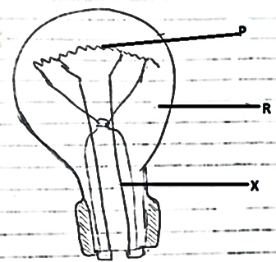
43. Below is an electric bulb. Use it to answer No. 43.

- Name part marked with letter P. ………………………..........................…………………
- Why is part marked with X important in a bulb?
…………………………………………………………………………………………………
- Name any gas which is found on part R.
…………………………………………………………………………………………………
- Which form of energy is stored in a bulb?
…………………………………………………………………………………………………

44. a) Why is a bat grouped under mammals?
……………………………………………………………………………………………………
b) Apart from bats, mention other two examples of mammals.
i)……………………………………………………ii)……………………………………………
c) How are bats important to crop farmers?
……………………………………………………………………………………………………
45. a) State one type of chicken which is kept by poultry farmers.
……………………………………………………………………………………………………
b) Write two reasons why people carry out poultry keeping.
i)……………………………………………………………………………………………………
ii)……………………………………………………………………………………………………
c) Suggest one problem faced by poultry farmers in Uganda.
……………………………………………………………………………………………………
46. a) Why is malaria referred to as a communicable disease?
……………………………………………………………………………………………………
b) Give one effect of diseases to human health.
……………………………………………………………………………………………………
c) Apart from malaria, give other two examples of communicable diseases.
i)……………………………………………………ii)……………………………………………

47. a) What do tape worms feed on?
……………………………………………………………………………………………………
b) Apart from tapeworms, mention any one example of intestinal worms.
……………………………………………………………………………………………………
c) State one sign of intestinal worm infection in the human body.
……………………………………………………………………………………………………
d) How do people control worm infections in the body?
……………………………………………………………………………………………………
48. Study the diagram below and answer the questions that follow
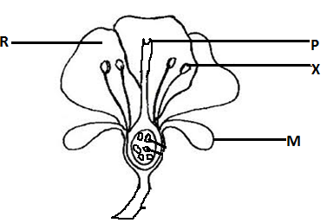

- State the function of part M on a flower.
……………………………………………………………………………………………………
b) Name parts marked with P and X
P ……………………………………………………… X…………………………………………
c) Why in some flowers part marked with R brightly coloured?
……………………………………………………………………………………………………
49. a) In which way are the following used as energy resource.
i) Animals………………………………………………………………………………………….
ii) Water ………………………………………………………………………………………….
b) Give one way how one can care for animals as a resource.
……………………………………………………………………………………………………
c) State one effect of floods in an environment.
……………………………………………………………………………………………………
50. a) What is the danger of poor personal hygiene on an individual?
……………………………………………………………………………………………………
- How are the following important in the promotion of personal hygiene?
i) Basin ……………………………………………………………………………………………
ii) Razorblade …………………………………………………………………………………………..

- Give one example of beddings as used in personal hygiene.
……………………………………………………………………………………………………
51. a) Name the acid which is found in the stomach of a person.
……………………………………………………………………………………………………
b) Which digestive juice contains salivary amylase enzyme?
……………………………………………………………………………………………………
c) State two ways one can do to promote the proper functioning of the digestive system.
i…………………………………………………………………………………………………
ii)………………………………………………………………………………………………
52. Match the following with their functions.
Eyes tasting
Ears touch
Skin sight
Tongue hearing
Eye ………………………………………………………………………………………………..
Ears ……………………………………………………………………………………………….
Skin ……………………………………………………………………………………………….
Tongue …………………………………………………………………………………………..
53. a) Write down one excretory organ.
………………………………………………………………………………………………….…
b) How are lungs important as respiratory organs?
………………………………………………………………………………………………….…
c) Mention two diseases which affect the respiratory organs.
i)………………………………………………ii)…………………………………………………
54. a)What would happen if rails of railway lines were fixed without gaps between?
………………………………………………………………………………………………….…
b) When does the sea breeze occur?
………………………………………………………………………………………………….…
c) State any other two applications of convection current in gas in our daily life.
i)………………………………………………ii)…………………………………………………
55. a) State one property of soil.
………………………………………………………………………………………………….…
b) In three sentences, explain how you would carry out an experiment to show that soil contains air.
………………………………………………………………………………………………….…
………………………………………………………………………………………………….…
………………………………………………………………………………………………….…
END

